4233645 - Division - Tax Product Export by Division
Division enhancement: Division-Based Tax Product Export (Epic 4233645)1. Customer Problemexports lack division filtering, forcing manual edits in tax products.
2. Customer Researchsupport single division, summary, or all divisions across PFX, Lacerte, GoSystem, UltraTax.
3. Our SolutionExport dialog adds Division scope selector.
- Map EM divisional TB to tax schemas per product.
Dependencies: export adapters for each tax product.
4. Product MetricsPost-export manual edits for division: -90%.
- Export success rate with division scope: >99%.
Appendix: Child Features4203849 Division-Based Tax Product Export
Appendix: Quick prototypePDF division set tables as user mental model for per-division outputs.
Appendix: LinksHYPERLINK "https://dev.azure.com/tr-tax/TaxProf/_workitems/edit/4233645"Open Epic 4233645

Appendix: Quick prototype
Figure: PDF page 67
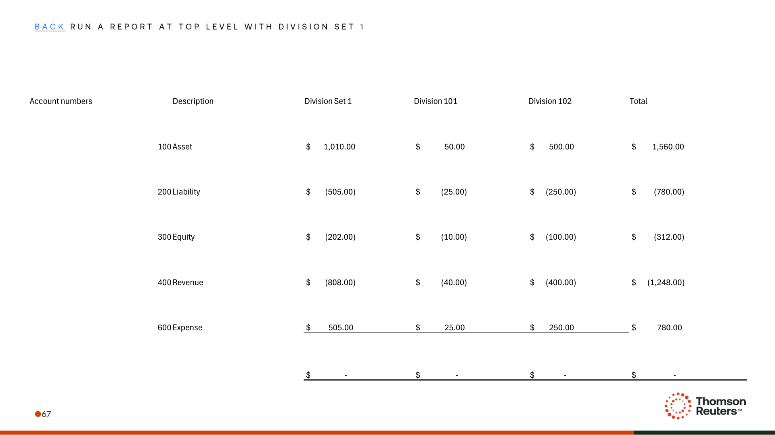
Figure: PDF page 71
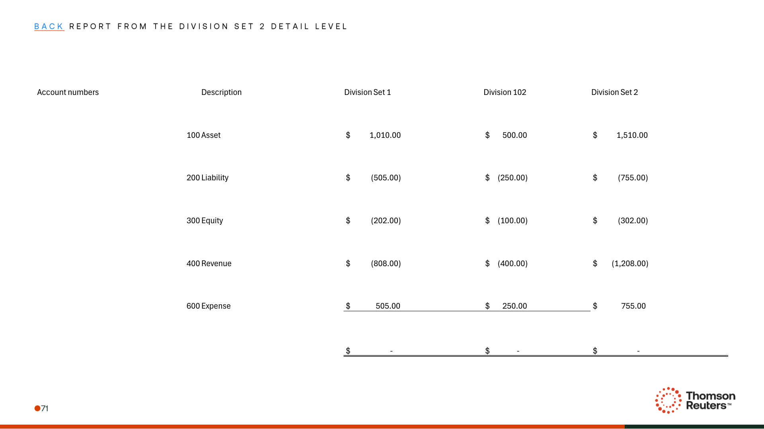
Figure: PDF page 72
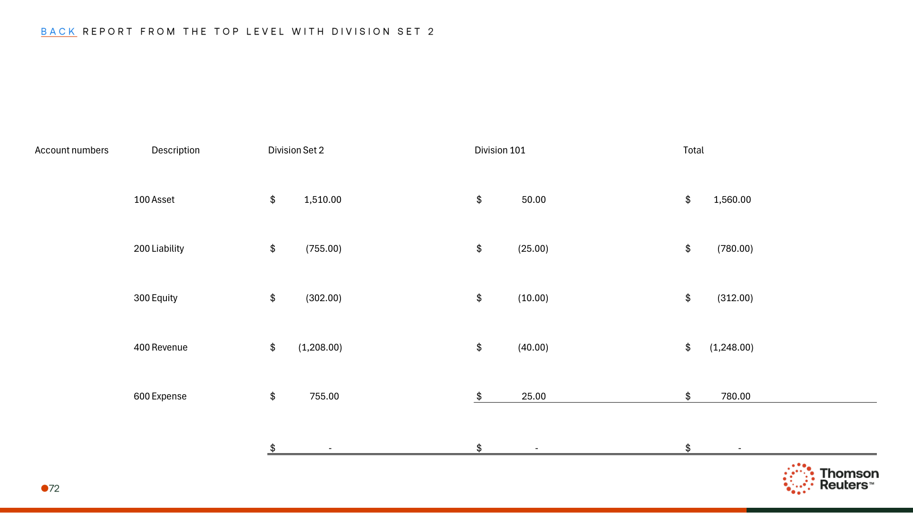

Appendix: Links
ADO Epic Link: https://dev.azure.com/tr-tax/TaxProf/_workitems/edit/4233645

